Name: Mushtaque Ali Khaskheli

Assignment: PF Lab 10

Sec: H

Task 1.
Input
#include <iostream>
using namespace std;
int main ()
{
cout<<"Five examples of Leap Year \n\n";
int year[5]={2004,2008,2012,2016,2020};
int*ptr;

ptr= year;
cout<<"\nYear Address\tYear Name\n";
for(int i=0; i<5; i++)
{
cout<<ptr+i<<"\t"<<*(ptr+i)<<endl;
}
return 0;
}
OUTPUT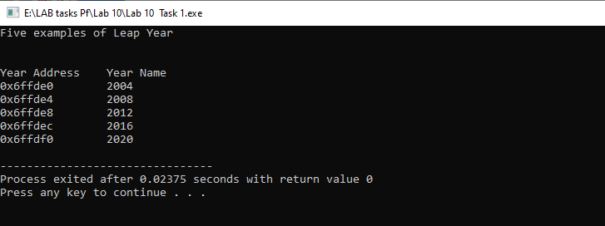
TASK 2.
Input
#include <iostream>
using namespace std;
int main ()
{
string team[5];
string*ptr;

ptr= team;
cout<<"\nEnter five Cricket Teams of the world \n";
for(int i=0; i<5; i++)
{
cout<<"Team "<<i+1<<" : ";
cin>>*(ptr+i);
}

cout<<endl;
for(int i=0; i<5; i++)
{
cout<<"Team "<<i+1<<" --> ";
cout<<*(ptr+i)<<endl;
}
return 0;
}
OUTPUT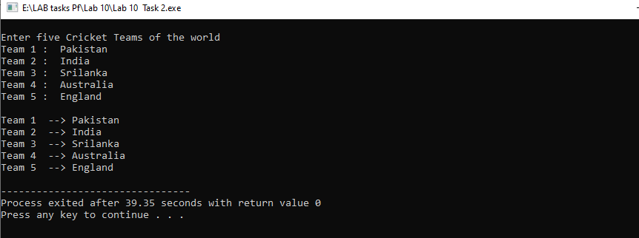

TASK 3.
INPUT
#include <iostream>
using namespace std;
int main ()
{
int num1, num2;
int*ptr1;
int *ptr2;

ptr1=&num1;
ptr2=&num2;

cout<<"\nEnter Number 1 : ";
cin>>*(ptr1);

cout<<"\nEnter Number 2 : ";
cin>>*(ptr2);

if(*(ptr1)==*(ptr2))
cout<<"\nThese are equal numbers \n\n";
else
cout<<endl<<*(ptr1)<<" and "<<*(ptr2)<<" are not equal ";
return 0;
}

OUTPUT
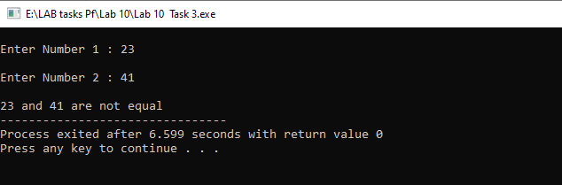
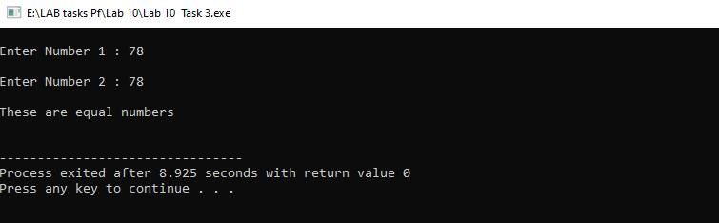

TASK 4.
INPUT
#include <iostream>
using namespace std;
void ReverseString(string &reverse)
{
char*ptr;
cout<<"\nString in REVERSE order\n";
for(int i=reverse.length()-1;i>=0; i--)
{
ptr[i]=reverse[i];
cout<<ptr[i];
}

delete[] ptr;
}
int main ()
{
string str;
cout<<"Enter a string \n";
getline(cin, str);

ReverseString(str);

return 0;
}

OUTPUT
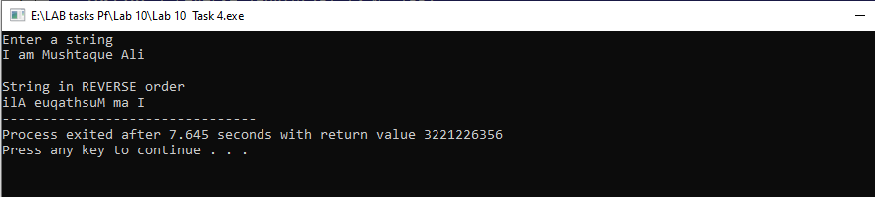

TASK 5.
INPUT
#include <iostream>
using namespace std;
void BubbleSort(int ptr[20])
{
for(int i=0; i<20; i++)
{
for(int j=0;j<20; j++)
{
if(ptr[j]>ptr[i])
{
int temp=ptr[j];
ptr[j]=ptr[i];
ptr[i]=temp;
}
}
}

}

int main ()
{
int arr[20]={3,2,1,4,3,10,5,34,23,2,444,23,45,6,6,5,4,3,44,34};
int*ptr;

ptr=arr;
cout<<"Values of Arrays in unsorted order \n";
for(int i=0; i<20;i++)
{
cout<<arr[i]<<" ";
}

BubbleSort(arr);
cout<<"\n\nValues of Arrays in sorted order \n";
for(int i=0; i<20;i++)
{
cout<<arr[i]<<" ";
}

return 0;
}

OUTPUT
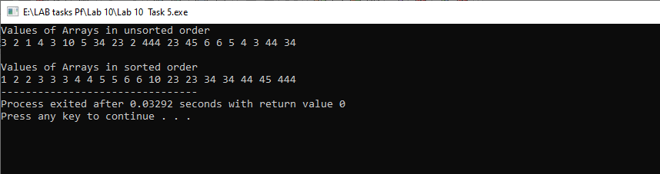
TASK 6.
INPUT
#include <iostream>
using namespace std;

int main ()
{
int arr[10], search, index;
bool check=false;
int*ptr;

ptr=arr;
cout<<"Enter 10 Values of Array \n";
for(int i=0; i<10;i++)
{
cout<<"ptr at index "<<i<<" = ";
cin>>*(ptr+i);
}

cout<<endl;
for(int i=0; i<10;i++)
{
cout<<"ptr at "<<i<<" index = "<<*(ptr+i)<<endl;
}

cout<<"\nEnter a number for searching : ";
cin>>search;

for(int i=0; i<10; i++)
{
if(search==*(ptr+i))
{
check=true;
index=i;
break;
}
}

if(check==true)
cout<<endl<<search<<" is present in the array at index "<<index;
else
cout<<endl<<"Sorry, "<<search<<" Not found ";
return 0;
}
OUTPUT
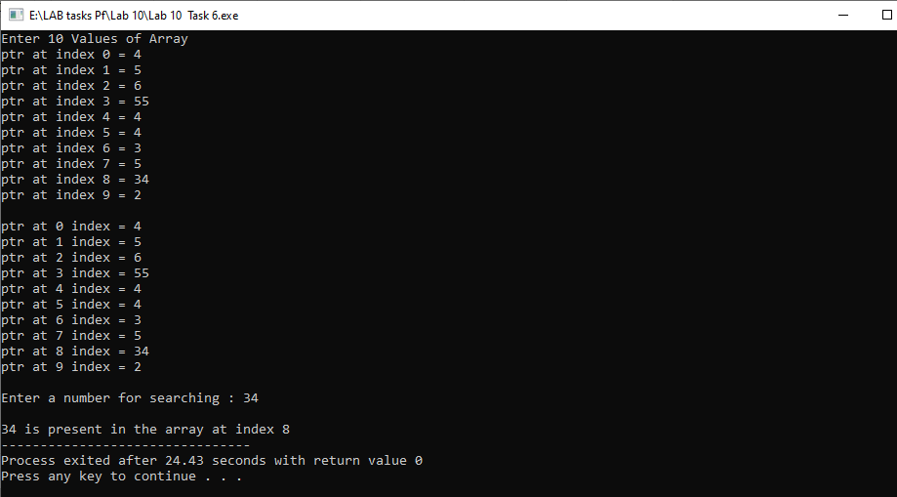
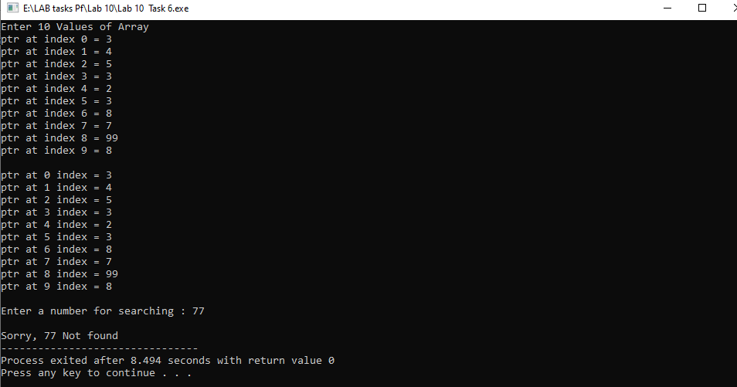

Task 7.
Input

#include <iostream>
using namespace std;
void swap(int *a, int *b)
{
*a=*a- *b;
*b=*a+ *b;
*a=*b- *a;
}
int main ()
{
int a=5, b=10;
cout<<"Before swaping: \n";
cout<<"\ta = "<<a<<"\tb = "<<b;

swap(&a,&b);
cout<<"\nAfter swaping: \n";
cout<<"\ta = "<<a<<"\tb = "<<b;
return 0;
}

Output
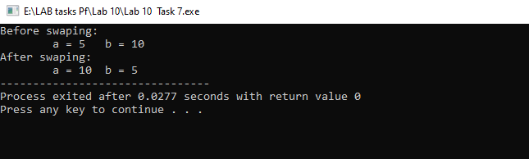

The End

